Bellotto:
Views on a Fortress

Large Print Text

Bellotto:
Views on a Fortress

Large Print Text
Introductory Room

[text starts from the large panel and runs clockwise round this small room]

Bellotto: Views on a Fortress
Introduction
Bernardo Bellotto (1722–1780) was born in Venice, the nephew and talented pupil of the celebrated view painter Canaletto (1697–1768). From him, Bellotto learned perspective and mastered the use of the camera obscura (pinhole camera) to help compose his views. Over time he became equally adept at evoking the varying textures, light and atmospheric effects of Venice. Bellotto was later employed at the courts of Dresden, Vienna, Munich and Warsaw, where he created highly original views.

Arriving in Dresden in 1747, Bellotto entered the service of Frederick Augustus II (1696–1763), Elector of Saxony and King of Poland (as Augustus III). Bellotto was the highest-paid artist at court and embarked upon the most productive decade of his career, painting 30 views of Dresden and its surroundings for the elector. His views of the fortress of Königstein originally formed part of that series but never reached their royal patron due to the escalation of the Seven Years’ War (1756–63). Instead, they were imported into Britain, probably during Bellotto’s lifetime. The paintings rested uncelebrated in private homes until the 1980s, when Manchester Art Gallery purchased the two fortress interior views. After over 250 years the Gallery is proud to unite them with two of the exterior views.

Exhibition organised by the National Gallery London and Manchester Art Gallery
Exhibition supported by Art Fund and the Manchester School of Art

This exhibition has been made possible as a result of the Government Indemnity Scheme. Manchester Art Gallery would like to thank HM Government for providing Government Indemnity and the Department for Digital, Culture, Media and Sport and Arts Council England for arranging the indemnity.
Der Zivilist Collective
(Emma Barnett, Celeste Coury, Olivia England, Xavier Mawer, Ross Miley)
Der Zivilist collective have created works in relation to the Bernardo Bellotto paintings and their context. Works include ‘recovered’ porcelain plates, bowls and platters, a ‘found’ journal, soundscapes, a magazine, and printed t-shirts. The displayed items offer a reflection on the materiality of artefacts, and on ideas of value that are created by institutional conventions. These creative responses suggest how we may construct imaginings of historical works and use them to understand our own lives and experiences.

The collective was established within a project between Manchester School of Art’s Unit X programme and Manchester Art Gallery. After a period of research alongside peers from across disciplines at the School of Art, Der Zivilist’s proposal was selected for collaborative development with the support of lecturers/artists Chester Tenneson and Jo Lansley, and Manchester Art Gallery staff.
Der Zivilist Collective
Celeste Coury

Coury’s ‘Der Zivilist’ magazine presents the history and broader context surrounding Bellotto’s work in a satirical format. Here is all you need to know about Bellotto in an alternative, digestible form.
The glossy aesthetic and modern design humorously challenge the collective’s idea that their work should be (mis)understood as found artefacts. The artist draws on a variety of popular magazines to pass comment on contemporary issues, including the culture of advertising and commercialism.
‘Der Zivilist’ magazine integrates the work of each group member, and further encourages people to question what they see and read, and to experience art on their own terms.
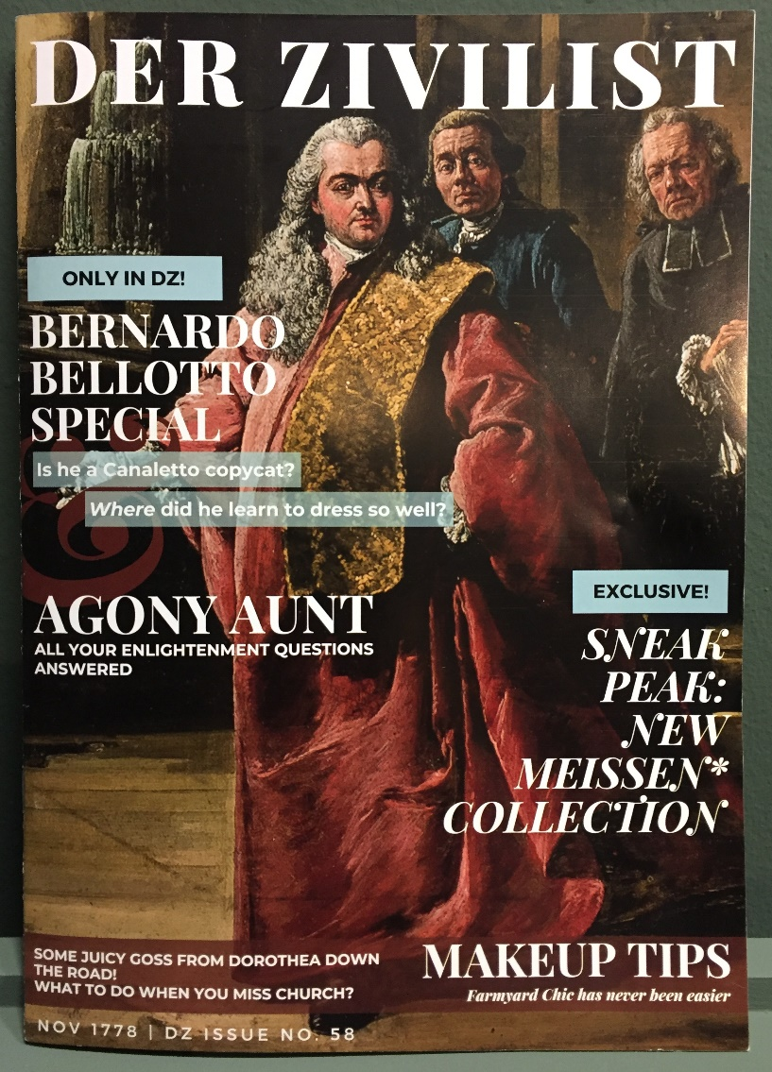

Der Zivilist 2021
Celeste Coury (she/her)
Printed magazine

Courtesy of the artist

Events
Lunchtime chats with curators and artists:
Staffage (the people in the paintings)
Thursday 25 November 2021 1pm-1.45pm

Making an exhibition
Thursday 9 December 2021 1pm-1.45pm

Bellotto’s story
Thursday 10 February 2022 1pm-1.45pm

The fortress
Thursday 24 February 2022 1pm-1.45pm

Public Talks
Bellotto’s Königstein: A Witness to History
With volunteer guide John Ward
Saturday 22 January 11am-11.45 am
Saturday 29 January 11am-11.45 am

Bellotto, Britain and the Königstein Paintings
With Stephen Lloyd, Curator of the Derby Collection
Saturday 19 February 2022 2pm-3pm

Workshop
Der Zivilist Masterclass
Art-making day for adults with artists from Der Zivilist collective based on their approaches and techniques. All materials provided. No previous art experience necessary.
Saturday 15 January 2022 11am – 4pm

All events are free but places are limited. For more details please visit our website, book in advance on Eventbrite, or speak to a member of staff.

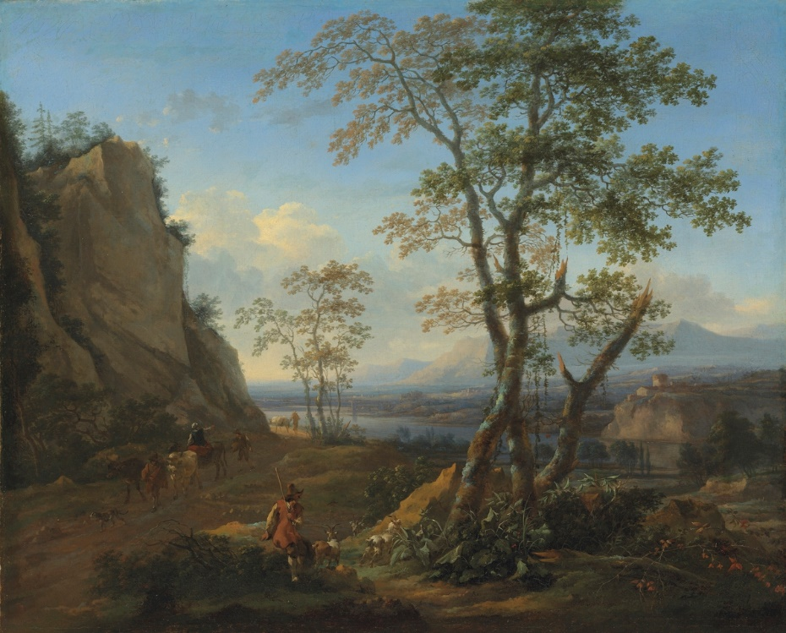
Photo © Christie’s Images

The Goatherd about 1640-83
Nicholaes Berchem 1620-83
Oil on canvas

Berchem was one of the Dutch artists whom Bellotto most admired. We know this because Bellotto occasionally copied groups of animals directly from his works. Displaying his freedom to play with international art like this helped Bellotto to raise his status as an artist, of which he was very conscious. Bellotto did not quote directly from this painting but it is a typical work by Berchem.

The two paintings of Königstein courtyard by Bellotto were purchased by Manchester Art Gallery in 1982-3. Historic paintings and other outstanding artworks from private collections still enter the public collection today, through the Acceptance in Lieu of tax scheme (AIL). The scheme enables taxpayers to transfer important works of art into public ownership as part of their inheritance tax bill. The Goatherd by Nicholaes Berchem is the Gallery’s most recent AIL acquisition.

Accepted by HM Government in Lieu of Inheritance Tax and allocated to Manchester Art Gallery
2020.61

Bellotto:
Views on a Fortress

Large Print Text
Central Room

[text starts with the painting on your left and moves clockwise round this central room]

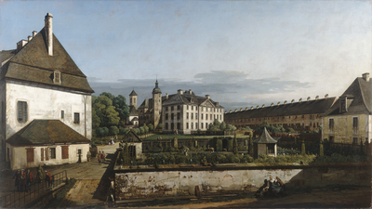
The Fortress of Königstein: Courtyard with the Brunnenhaus 1756–8
Bernardo Bellotto 1722-80
Oil on canvas

Bellotto displays his mastery of perspective in this carefully constructed view, with the foreshortened buildings and sharply receding path indicating his use of a camera obscura. The spiny row of chimneys on the rooftop of the Old Barracks and the mirroring, tree-lined pathway draw our eye towards the Brunnenhaus. This housed the well that provided the fortress with fresh water.

At the front is the crumbling perimeter of a walled garden, its flaking plaster and underlying brickwork rendered in miniaturist detail. Its state of disrepair offers a stark contrast to the manicured topiary and colourful rose beds beyond, where a stooping gardener can be seen tending to the plants. Outside, a senior military figure is followed by a man in traditional Polish dress, a common sight at the court of Augustus III, who was both Elector of Saxony and King of Poland.

Purchased with the assistance of the Victoria and Albert Museum Purchase Grant Fund, the National Heritage Memorial Fund, Art Fund, the Manchester Art Gallery Art Fund, Patrons, Associates and Friends of Manchester Art Gallery 1982.712

The Persistence of Walking 2021
Xavier Mawer (they/them)
Soundscape; duration three minutes
Plays at forty minutes past the hour.
Scan to listen at any time:

On loan from the artist LI2021.8.5

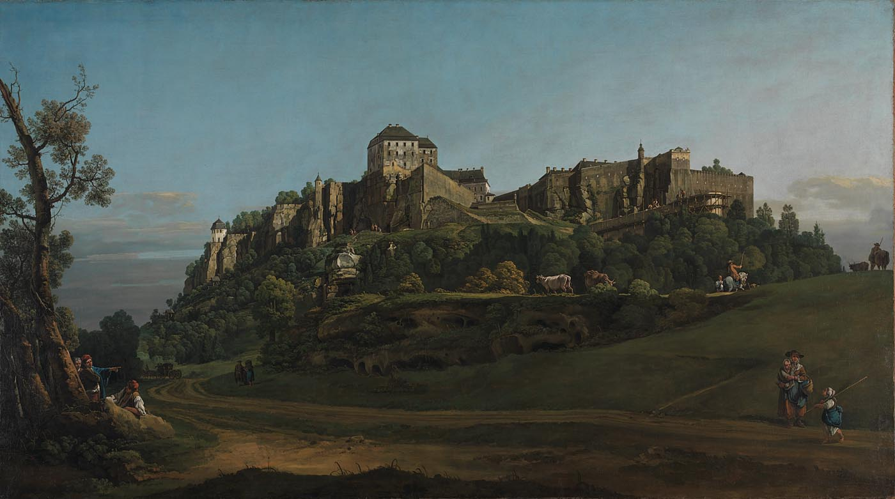
© The National Gallery London
The Fortress of Königstein from the North 1756–8
Bernardo Bellotto 1722-80
Oil on canvas

Bellotto’s view is taken from the edge of a sandy track that meanders through the valley. The imposing structure of the fortress, with its jagged profile, is exaggerated by his low vantage point and proximity to the site. The artist delights in depicting different textures: from the crumbling plasterwork of the fortress walls, picked out with meticulous precision, to the vegetation surrounding it, captured in spirited brushstrokes. Tiny soldiers, created with just a few dots of paint, stand guard high on the ramparts. To the right a shepherd leans wearily against a cow, resting at the end of a long day in the sun, while others relax under a tree in the foreground. As with his other exterior view of the fortress Bellotto borrowed these motifs from engravings after works by Nicolaes Berchem (1620–83) and Francesco Zuccarelli (1702–88).
The National Gallery, London

Bought with the support of the American Friends of the National Gallery, The National Gallery Trust, the Estate of Mrs Madeline Swallow, Art Fund (with a contribution from The Wolfson Foundation), Howard and Roberta Ahmanson, The Deborah Loeb Brice Foundation, Mrs Mollie W. Vickers, The Manny and Brigitta Davidson Charitable Foundation and The Sackler Trust, with additional support from Mrs Charles Wrightsman, Jean-Luc Baroni, The Linbury Trust, The Monument Trust, Mr Fabrizio Moretti, Sir Hugh and Lady Stevenson, The John S. Cohen Foundation, Mr Jonathan Green, Christoph and Katrin Henkel, Ernst Nissl, Mr Peter Scott CBE QC, Mr and Mrs Ugo Pierucci, Sir Michael and Lady Heller, Mr Adrian Sassoon, Mr Mark Storey, Mr Neil Westreich, Nicholas and Judith Goodison, John and Flavia Ormond and other donors including those who wish to remain anonymous, 2017 NG6668
The Physical Impossibility of Burps in the Mind of Someone Mooing 2021
Xavier Mawer (they/them)
Soundscape; duration three minutes
Plays at ten minutes past the hour.
Scan to listen at any time:
On loan from the artist LI2021.8.2

Bellotto: Views on a Fortress
The Fortress of Königstein
Königstein, meaning literally ‘king’s stone’, is located approximately 25 miles south-east of the city of Dresden, in eastern Germany. During its 800-year history, this impressive rocky outcrop has served as a castle, a monastery, a fortress, a state prison, a prisoner-of-war camp, a military hospital and a safehouse for royal treasures.

Overlooking the River Elbe, in an area of outstanding natural beauty known as ‘Saxon Switzerland’, the fortress remains largely unchanged to this day. In 1756, Bernardo Bellotto’s most prestigious patron, the Elector of Saxony, commissioned him to paint five large-scale views of Königstein. The historic significance of the fortress was reinforced in the elector’s own lifetime, for it was here that he and his sons barricaded themselves at the onset of the Seven Years’ War, before taking flight to Warsaw.

Bellotto’s approach to the task was unprecedented: he obtained special permission to make drawings in situ and produced monumental paintings of the fortress, captured from both outside and within its forbidding walls. Bellotto clearly recognised the site’s dramatic possibilities and relished the opportunity of setting this majestic stronghold in its breath-taking surroundings, silhouetting its craggy, angular form against an open sky.

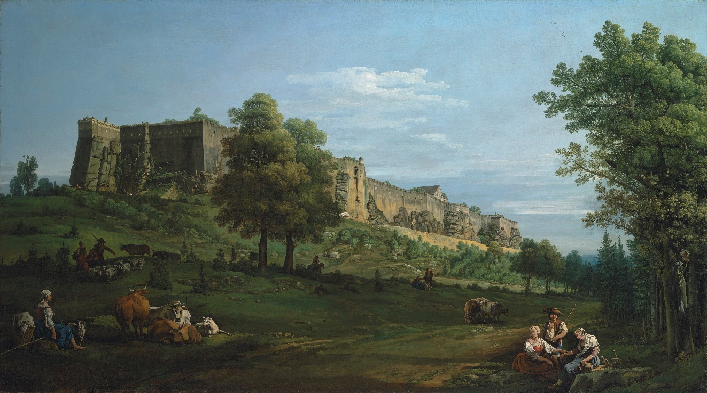
Image reproduced courtesy of the Rt Hon. The Earl of Derby / Photo © Christie’s Images

The Fortress of Königstein from the South-West 1756–8
Bernardo Bellotto 1722-80
Oil on canvas

Here Bellotto gives us an entirely different perspective of Königstein, not least because very little can be seen of the buildings within. An impenetrable bank of sheer, sandstone walls makes life inside the fortress seem distant and inaccessible, and our view of the site is further obscured by two trees. The ‘Horn’ promontory marking the far-left corner is also visible on the right side of Bellotto’s view from the north.

As the fortress rises from the brow of the hill, it forms a looming presence on the escarpment, marking a strong diagonal across the canvas that draws our eye along the receding, sun-bleached walls. By depicting Königstein at this oblique angle, Bellotto demonstrates his skill and originality in conceiving sophisticated compositions with bold foreshortenings. The regimented precision with which he has painted the fortification is at odds with his loose handling of the trees’ foliage and the fluffy white clouds above.

Lent by The Earl of Derby
The Girl with the Feather Earring 2021
Xavier Mawer (they/them)
Soundscape; duration three minutes
Plays at twenty minutes past the hour.
Scan to listen at any time:
On loan from the artist LI2021.8.3

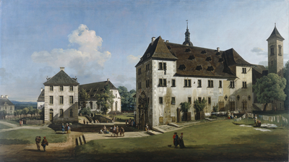

The Fortress of Königstein: Courtyard with the Magdalenenburg 1756–8
Bernardo Bellotto 1722-80
Oil on canvas

Bathed in sunlight, the fortress courtyard is replete with quiet civilian life. Only a glimpse of the distant landscape reminds us that this island of civilisation floats above the rolling Saxon countryside. The elegant structure of the Magdalenenburg, a Renaissance-style castle built in the seventeenth century for courtly festivities, dominates the composition. It was home to a 60,000-gallon wine cask, the location of which is indicated by three round ventilation points visible at the far right.
Bellotto offers vignettes of daily life at the fortress: women talk as they lay out their laundry on lush green grass and makeshift lines, and a lady with a parasol, accompanied by two gentlemen, admires the intricate stone portal. Sharp shadows demonstrate Bellotto’s sophisticated control of light. It is a mystery why he decided to paint the shadow cast by the woman and soldier in the foreground as falling in the wrong direction.

Purchased with the assistance of the Victoria and Albert Museum Purchase Grant Fund, the National Heritage Memorial Fund, Art Fund, the Manchester Art Gallery Art Fund, Patrons, Associates and Friends of Manchester Art Gallery 1983.806
The Birth of Laundry 2021
Xavier Mawer (they/them)
Soundscape; duration three minutes
Plays at thirty minutes past the hour.
Scan to listen at any time:
On loan from the artist LI2021.8.4

Bellotto:
Views on a Fortress

Large Print Text
Far Room
[text starts from the left as you go in and runs clockwise]
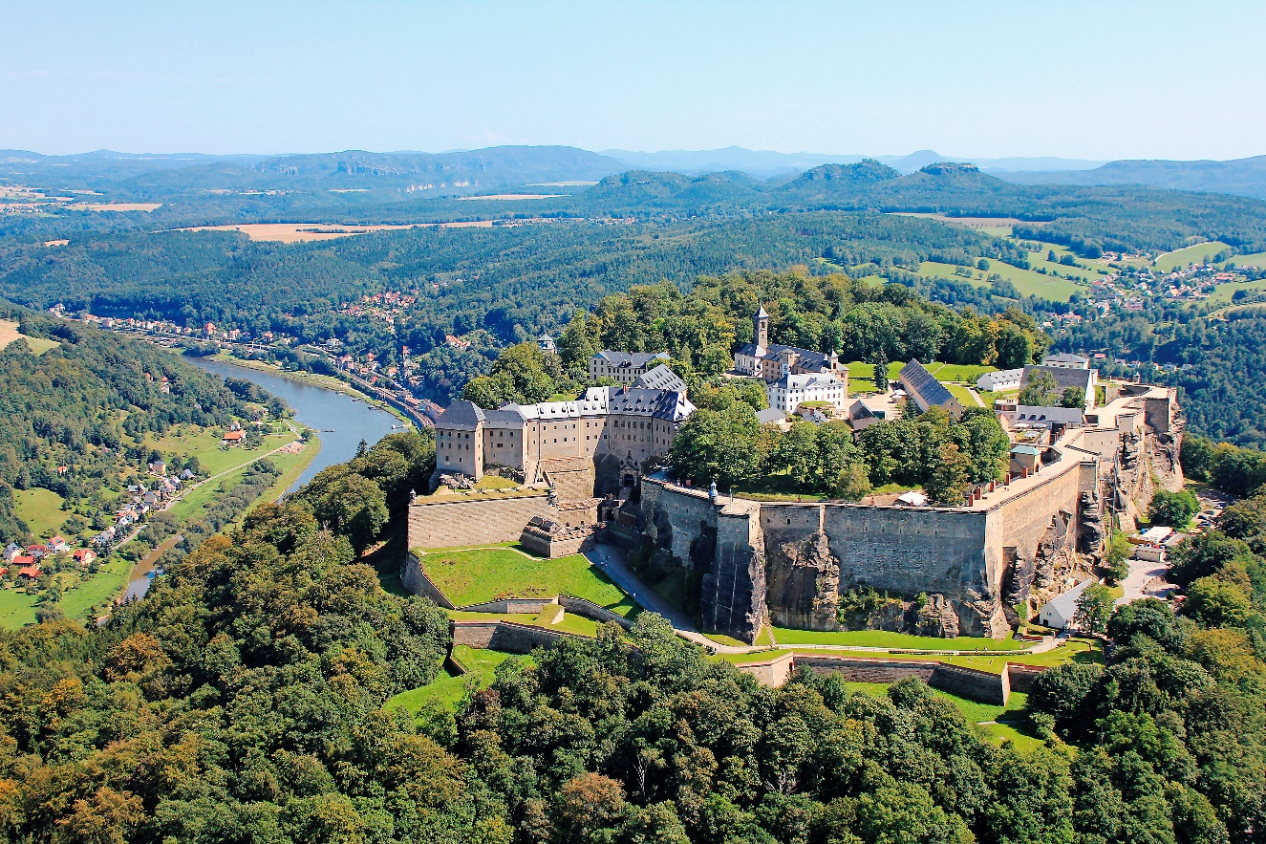The fortress of Königstein today (aerial photograph taken from the north-west)
© akg-images / euroluftbild.de. Photo: Harald Anders

Der Zivilist Collective
Xavier Mawer

The soundscapes accompanying the paintings allow the viewer to fully immerse themselves within each piece, placing them in the shoes of the people depicted. Mawer uses this approach to highlight a number of differences and similarities between now and the 18th century, and make our human connection to the people who lived in and around the fortress more tangible.
Der Zivilist’s signature irony, that runs throughout the group’s exhibition, is accentuated through Mawer’s addition of sounds that collide with the suggested tranquillity of the bucolic setting.

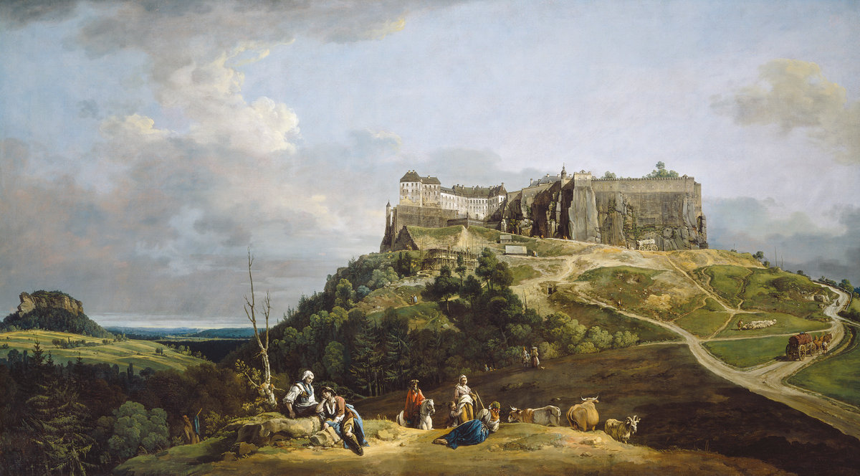
The Fortress of Königstein from the North-West 1756-8
Bernardo Bellotto 1722-80
Courtesy National Gallery of Art, Washington

The Americans Kep’it 2021
Xavier Mawer (they/them)
Soundscape; duration three minutes
Plays on the hour.
Scan to listen at any time:
On loan from the artist LI2021.8.1
[low display case]

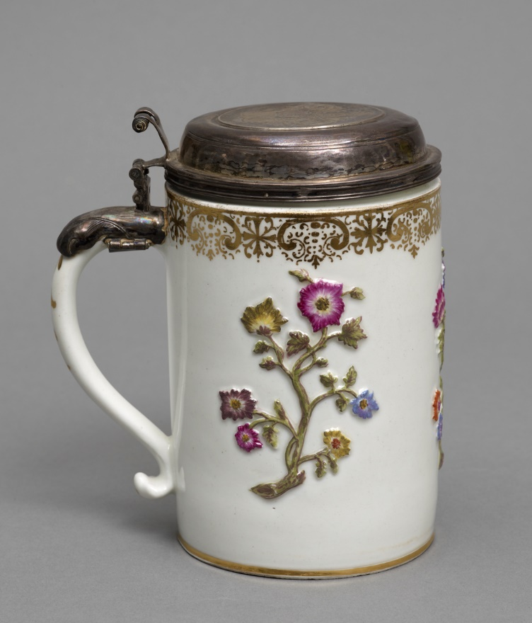

Covered tankard about 1720
Designed by J F Bottger, manufactured by Meissen
Hard paste porcelain with silver cover

Johann Friedrich Böttger, the designer of this tankard, was imprisoned at Königstein in 1706-7. It was during this period that he claimed to have cracked the formula for making porcelain.
Dr Frederick Lacks and Dr Erna Lacks Bequest 1981.345
[above low display case]
Der Zivilist Collective
Olivia England

This hand-crafted journal is filled with speculative detail from the life of Johann Friedrich Böttger, inventor of hard paste porcelain and prisoner of Königstein fortress, years previous to Bellotto’s arrival. England has layered digital imagery and collage to generate a scrapbook of jottings and sketches Böttger could have designed. At first glance the journal appears to be a historic document, but by using a mix of contemporary tools and a freshness of finish England nods to the present.

[low display case]

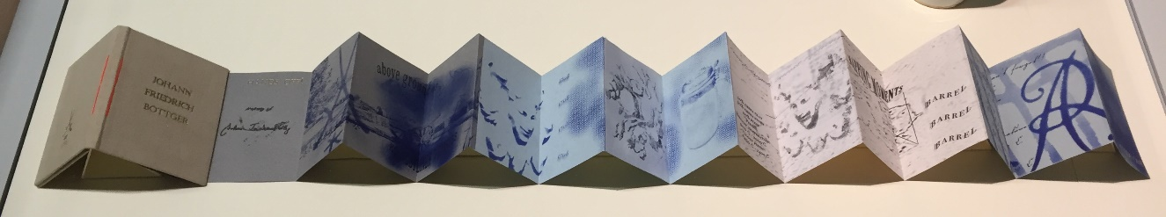

The Journal of Johann Friedrich Böttger 2021
Olivia England (she/her)
Handmade concertina-format hardcover notebook
with gold-embossed fabric cover and thread detail;
inside pages risograph print on paper.

On loan from the artist LI2021.7.1
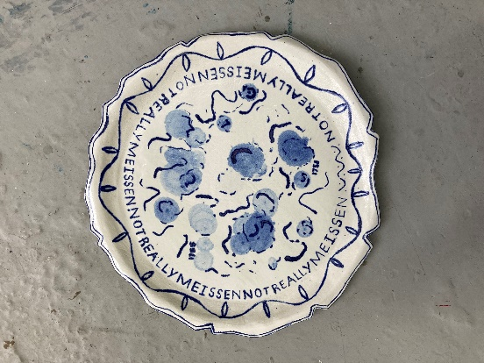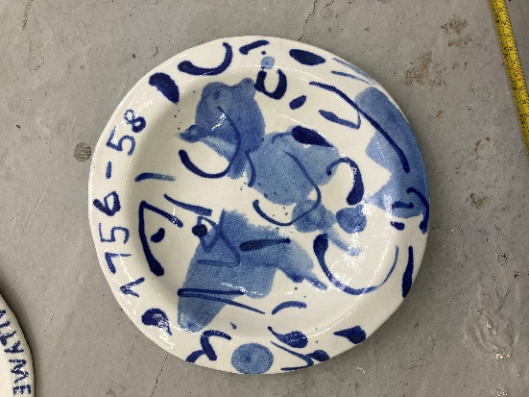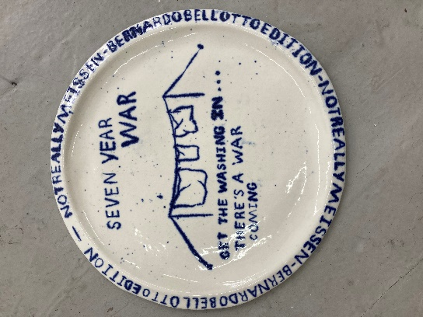
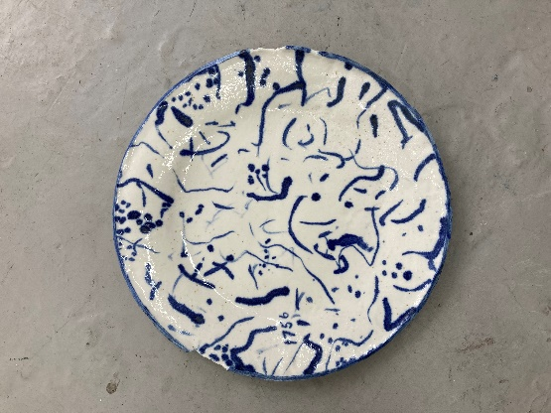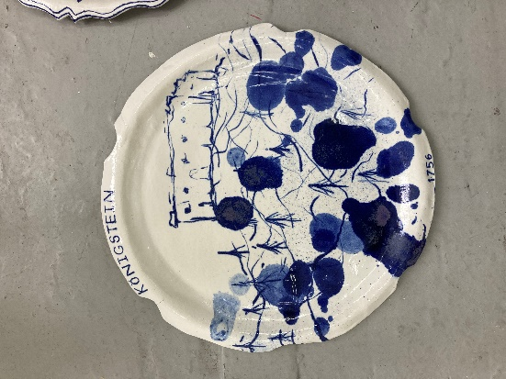

Untitled 2021
Ross Miley (he/him)
5 porcelain plates with cobalt oxide glaze decoration

On loan from the artist LI2021.1

Der Zivilist Collective
Ross Miley

Miley has created porcelain artefacts apparently ‘recovered’ from Königstein Fortress. He has selected imagery from the paintings and the historic context of the time and used modern splashes and washes of cobalt oxide to mix contemporary mark making with historical reference. By displaying an item of Meissen porcelain from the Gallery’s collection with these new artworks the artist visually plays with real and imagined histories, and leaves space for the viewer to bring their own connections and understandings.
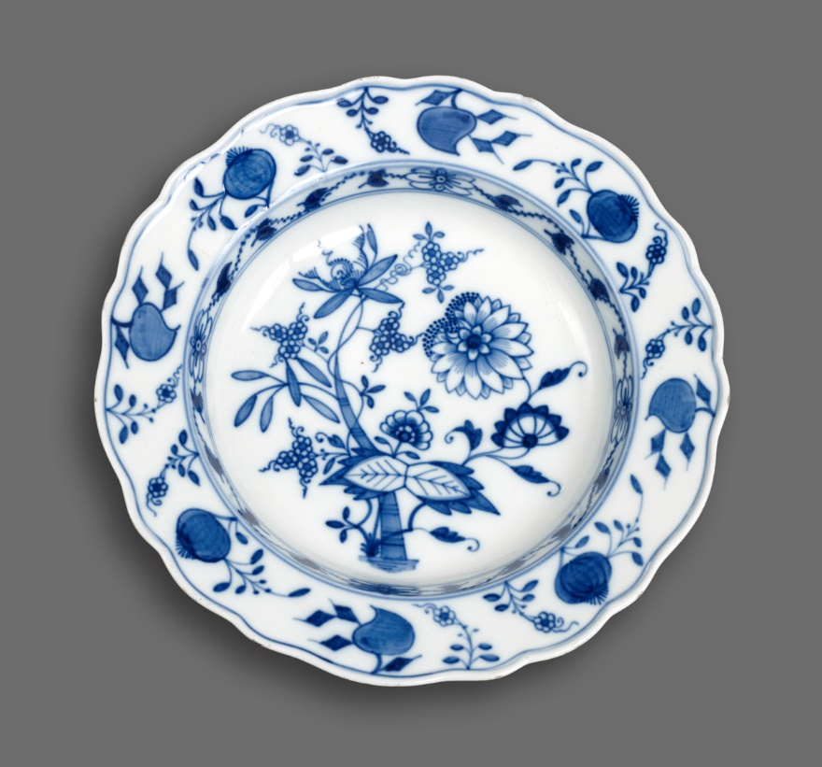

Soup dish about 1880
Manufactured by Meissen
Hard paste porcelain

Transferred from the Horsfall Museum Collection 1918.179

[Tall display case]
Der Zivilist Collective
Emma Barnett

Through illustrations presented on t-shirts, Barnett hints at a story of clothing being sold on stalls to passing travellers or militia visiting Königstein.
One t-shirt mirrors Bellotto’s style of anecdotal painting and turns it into a sentimental souvenir. The second re-works a graphic slogan motif of the kind used in contemporary tourism and band merchandise. ‘Make Ceramics Not War’ is an altered quote from Fredrick II, King of Prussia (reign 1740-86), who remarked that the Saxons would be better making ceramics than going to war.
Extending themes of value and reproduction that run through Der Zivilist’s work, these T-shirts are available in the gallery shop.

[Tall display case]
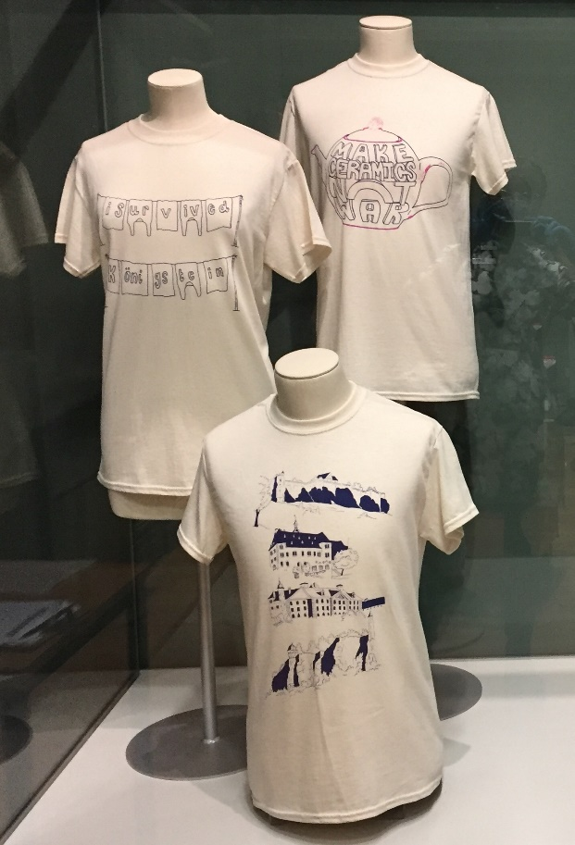
T-shirts 2021
Emma Barnett (she/her)
Screenprints; ink on readymade cotton t-shirts

On loan from the artist LI2021.2.1 & LI2021.2.2

[Tall display case, on shelf]]
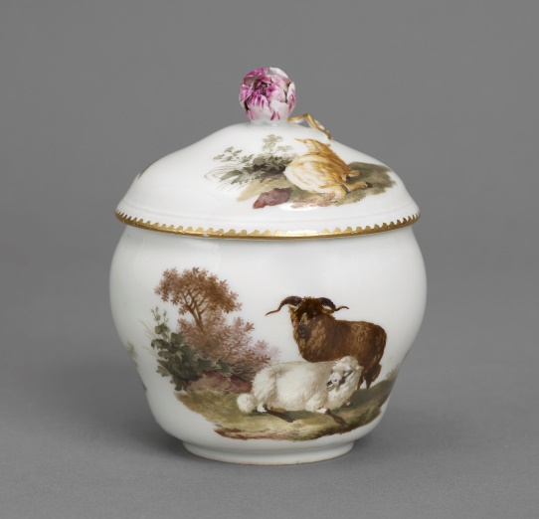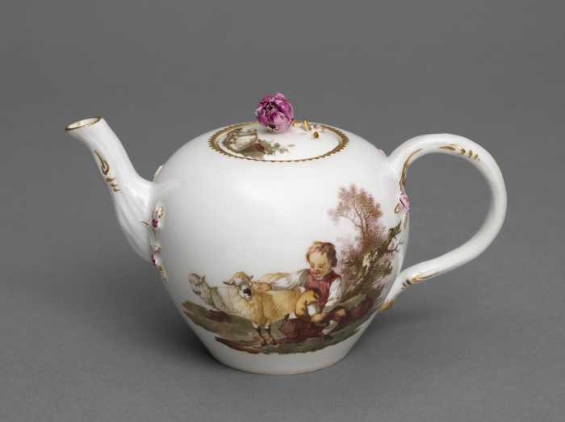
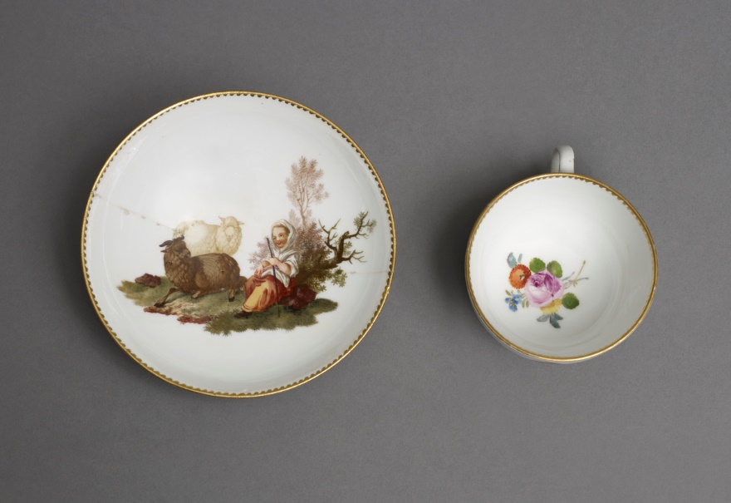

Tea pot, sugar bowl and cup with saucer
about 1775
Manufactured by Meissen
Hard paste porcelain

George Beatson Blair bequest 1947.737, .739, .745

[Tall display case, below shelf]
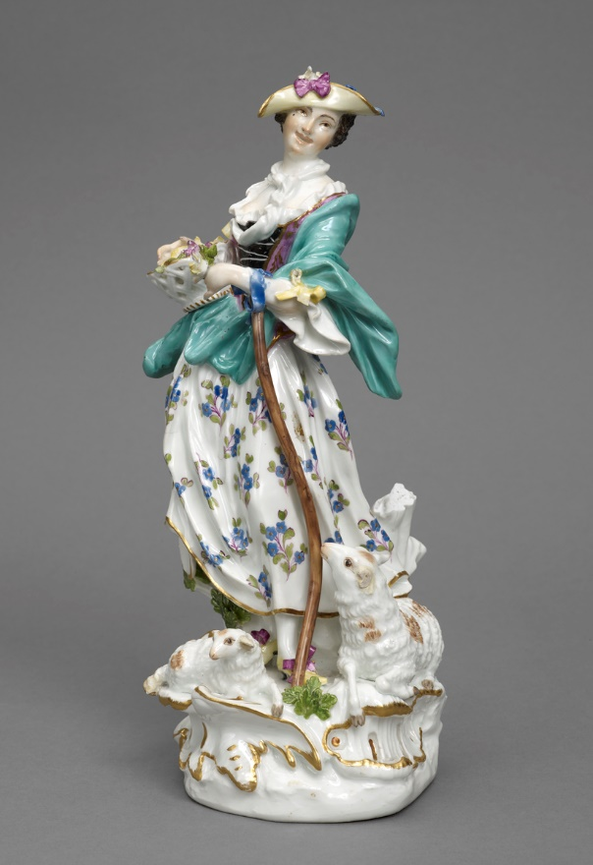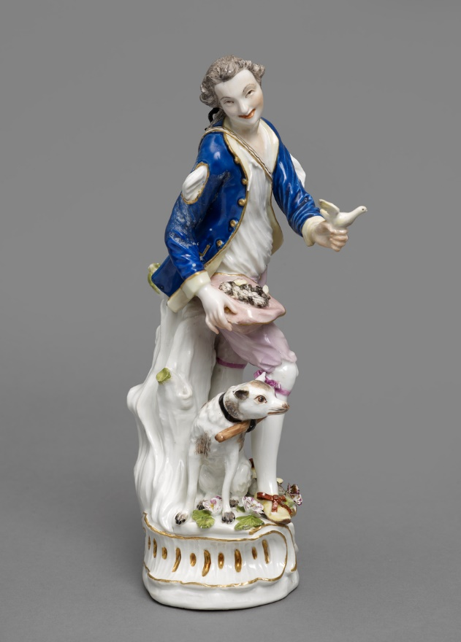

Figures of a shepherd and shepherdess 1750-55
Shepherdess modelled by J J Kaendler
Both manufactured by Meissen
Hard paste porcelain

Purchased 1984.750, .751

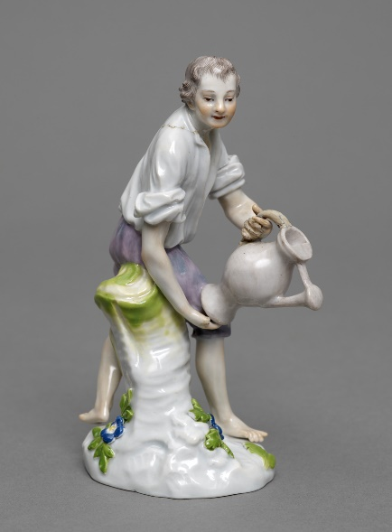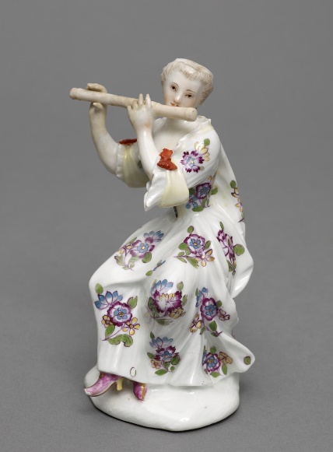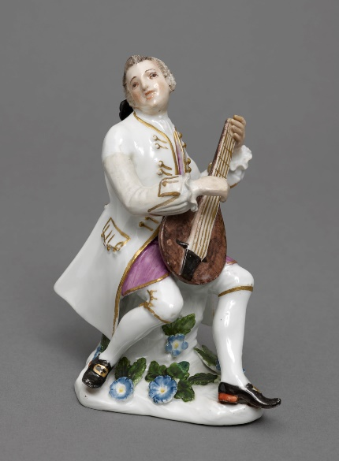

Three figures 1743-45
Possibly designed by
Johann Joachim Kaendler 1706-75
or Peter Reinicke 1715-68
Manufactured by Meissen
Hard paste porcelain

Leicester Collier Bequest 1917.383, .384, .386

Meissen and Bellotto
The connection between Meissen porcelain and Bernardo Bellotto is Königstein fortress.
Frederick Augustus II (1696–1763), Elector of Saxony and King of Poland (as Augustus III) commissioned Bellotto to paint Königstein in 1756.
The previous elector, Frederick Augustus’s father, known as Augustus the Strong, had on staff an alchemist, Johann Friedrich Böttger (1682-1719). Böttger’s progress at turning base metal into gold was slow. In 1706, to focus his mind, Augustus locked him up in Königstein with scientist Ehrenfried Walther von Tschirnhaus (1651-1708). Tschirnhaus had a different project in hand: to crack the formula for making porcelain. Rich and royal Europeans had been hankering after this precious Chinese ceramic for centuries. Its extreme hardness made delicate, near-transparent creations possible.
Imprisonment was effective: Böttger and Tschirnhaus found the formula in 1708 - kaolin clay, alabaster, China stone and quartz, heated to 1300 degrees centigrade. After Tschirnhaus died, Böttger took all the credit. He became the first director of the Meissen porcelain manufactory in 1710.
Der Zivilist collective have identified Meissen porcelain in the gallery collection to display. Their selections present another way to interweave the stories of the fortress, Bellotto, Meissen, and, now, Manchester.

All images © Manchester Art Gallery unless otherwise credited

